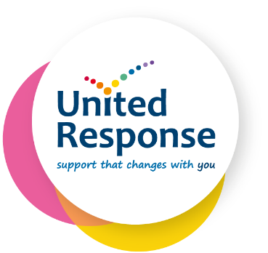
Gift Aid Declaration

Boost your donation by 25p of Gift Aid for every £1 you donate
Gift Aid is reclaimed from the tax you pay for the current tax year. Your address
is needed to identify you as a current UK taxpayer.
In order to Gift Aid your donation you must tick the box below:
☐ I want to Gift Aid my donation of £______________ and any donations I make in the future or have made in the past 4 years to United Response.
I am a UK taxpayer and understand that if I pay less Income Tax and/or Capital Gains Tax than the amount of Gift Aid claimed on all my donations in that tax year it is my responsibility to pay any difference.
My Details
Title ____________________ First name or initial(s) ____________________________
Surname ________________________________________________________________
Full Home address ________________________________________________________
________________________________________________________________________
________________________________________________________________________
Postcode __________________________ Date _________________________________

Please notify us if you:
- Want to cancel this declaration
- Change your name or home address
- No longer pay sufficient tax on your income and/or capital gains

If you pay Income Tax at the higher or additional rate and want to receive the additional tax relief due to you, you must include all your Gift Aid donations on your Self-Assessment tax return or ask HM Revenue and Customs to adjust your tax code.
Please complete and return to: fundraising@unitedresponse.org.uk
OR post to United Response, Fundraising Team, 7th Floor, Knollys House, 17 Addiscombe Road, Croydon, CR0 6SR

